ABSTRACT TEMPLATE FOR THE ACCC DOCTORAL PROGRAMME WORKSHOP

A.B. ONE¹, C.D. TWO², E. THREE^{1,2} and F. FOUR³

¹ Department of Physics, University of Helsinki, Finland
² Department of Applied Physics, University of Eastern Finland, Finland
³ Finnish Meteorological Institute, Helsinki, Finland

Keywords: nucleation, atmospheric aerosols, water, sulphuric acid, ammonia
Aerosol Theme: Which of the five themes (see webpage) best describes the work?

Start typing text here (about 7cm from the top of the page, depending on the length of the title and the number of addresses). Use 10 pt Times New Roman font (except for the title, which should be in 12 pt bold and in upper case). Centre the title, the authors' names, the addresses, and keywords. For the body of the abstract, start each paragraph with a tab, and use tab settings of 1 cm. Justify the body of the text both left and right.
The abstract should be in double column (like this example), and a maximum of one page long. Use A4 page set-up and make top and bottom margins 25 mm wide, left and right margins 22 mm wide. You can include up to five keywords. The keywords should describe your work in the broader context as well as possible.
Figures and Tables may be included in the abstract, but make sure that they have a caption, and that they are numbered consecutively using Arabic numerals. All the Figures and Tables must be referred to in the abstract text. The font used in captions should be 10 pt. If the caption is shorter than one full line, it should be centred like in Table 1. If it is longer, it should be justified both left and right like in Figure 1. Vertical lines in tables should be avoided. Equations should be centred and numbered consecutively, like in the example below:
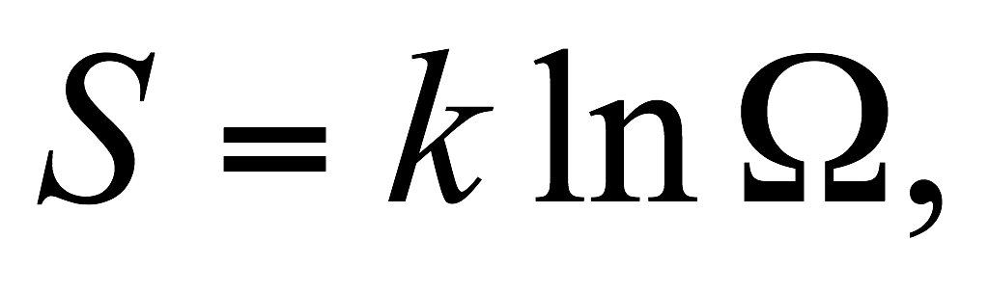(1)
where S is entropy, k is Boltzmann’s constant, and Ω is the number of microstates.
Day | Number [cm⁻³] | Mass [⎧g m⁻³]
January 23 | 2050 | 4.7
April 5 | 12800 | 8.5

Table 1: Measured properties of aerosol.

References should be made in the style (Noppel et al., 2002; Hale and DiMattio, 2000), or simply refer to Seinfeld and Pandis (2006). Examples of references are shown in the reference list in the end of the abstract. Leave a blank line above the list with references (and also above the acknowledgements). Use of hyperlinks is also allowed as demonstrated in the abstract submission paragraph.
Authors are invited to submit a one page abstract related to aerosol science. The abstracts will be reviewed by the symposium organisers and the NOSA
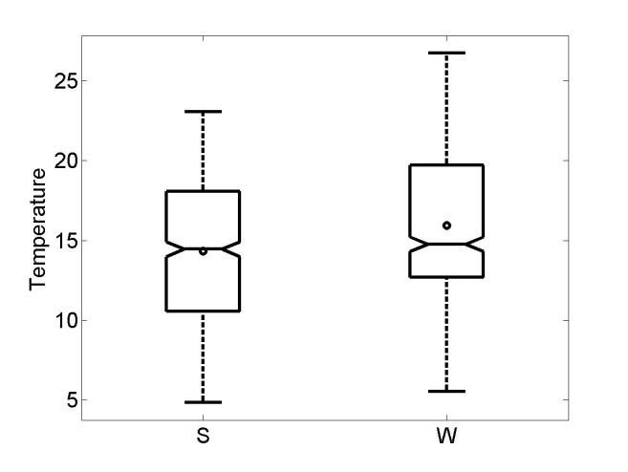
Figure 1: The temperatures in the summer and in the winter.

board according to scientific content, suitability for the symposium and form. Abstracts which do not fulfil the standards will be rejected. Please, avoid submitting abstracts containing only future results. The abstract should be submitted in PDF format to:
nosa.conference@gmail.com. When preparing the final PDF, make sure that the page size is A4!

Hale, B. N. and DiMattio, D. (2000). In Hale, B. and Kulmala, M., editors, Proceedings of the 15th International Conference on Nucleation and Atmospheric Aerosols, pages 31-34, Berlin, Heidelberg, New York. American Institute of Physics Conference Proceedings, Springer Verlag.
Noppel, M., Vehkamäki, H., and Kulmala, M. (2002). J. Chem. Phys., 116:218-228.
Seinfeld, J. and Pandis, S. (2006). Atmospheric Chemistry and Physics: From Air Pollution to Climate Change. Wiley Interscience, 2nd edition.

